Name____________________________________________________

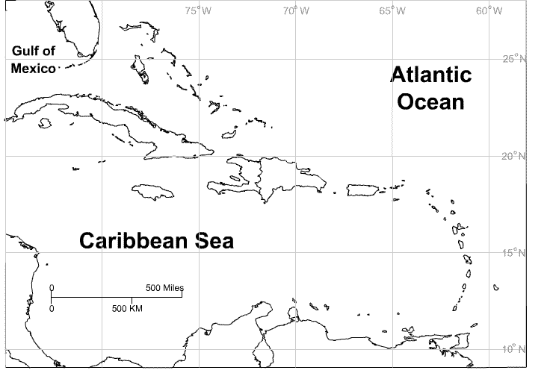

Countries
Cuba

Jamaica

Haiti

Dominican Republic

Bahamas

Puerto Rico

Dominica

Barbados

St. Lucia

St. Vincent and the Grenadines

Trinidad and Tobago

St. Kitts and Nevis

US Virgin Islands

Guadeloupe

http://lizardpoint.com/geography/images/maps/748x507xcarib-islands-labeled.gif.pagespeed.ic.7OCtGkmmXi.png

