Name_____________________________________________

\
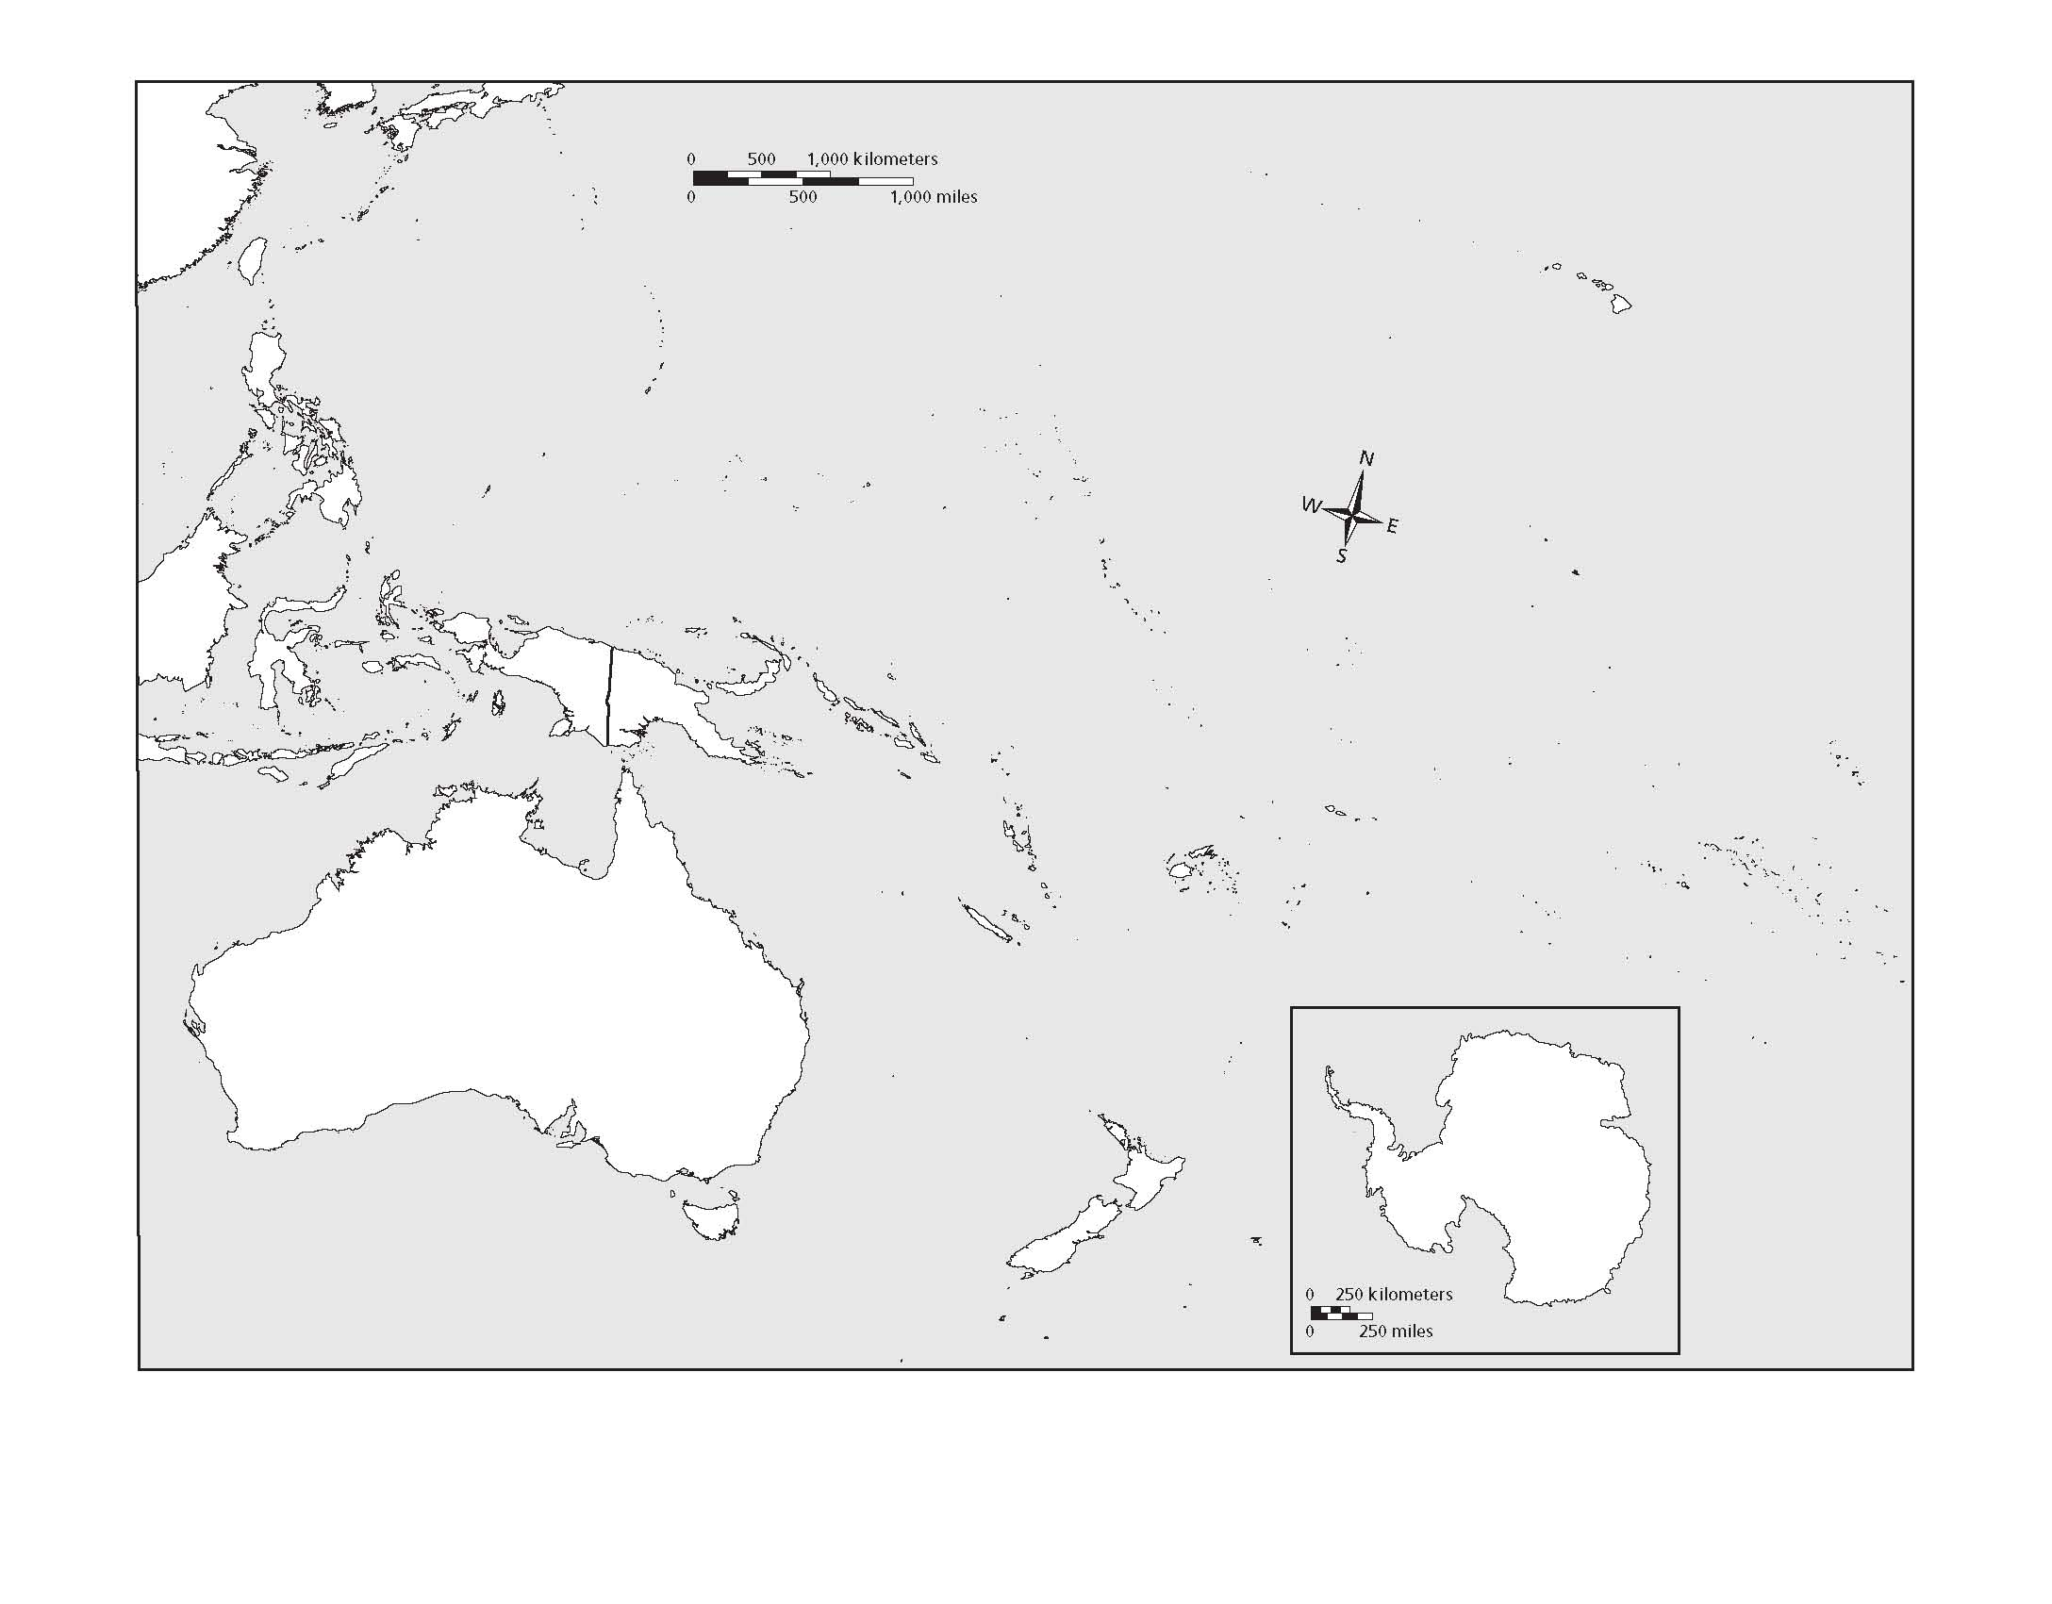

Countries
Australia
Antarctica
New Zealand
Papua New Guinea
Tasmania
Fiji
Solomon Islands
Vanuatu
Micronesia
American Samoa

